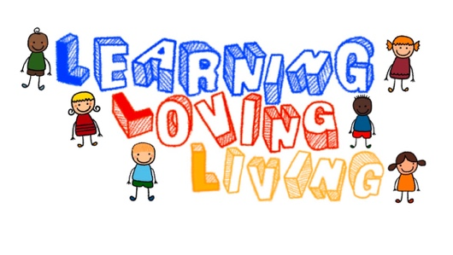
June Bugs Application 2026
Our June Bugs program is a three week camp type program that runs from 8:40-12:40 (Preschool class)/8:50-12:50 (Pre-K class) four days per week. We will spend most of the time outside (weather permitting). Each child should bring a nut free, sesame free lunch to school, snacks will be provided. You will be provided more detailed information about our daily schedule and what to send with your child as it gets closer. Be prepared for lots of fun in the sun and extra play time with friends.

Child’s Name:___________________________________

Total weeks requested for June Bugs:

_____ 1 Week $215

_____2 Weeks $430

_____3 Weeks $645

Payment due April 1, 2026

June Bugs Weeks:

___________Week of 1: May 26-May 29 (Tuesday – Friday)

___________Week 2: June 1-4 (Monday – Thursday)

___________Week 3: June 8-11 (Monday – Thursday)

